 | 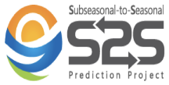 |  | 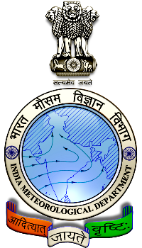 | 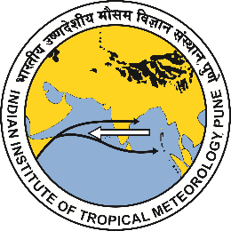

Seventh WMO International Workshop on Monsoons (IWM-7)
Online Training Workshop on
Subseasonal to Seasonal (S2S) Prediction of Monsoons
1-12 November 2021

Registration Form for Participation
Preferably use online form at https://icmpo.tropmet.res.in/iwm7training.php, but you can also send this form, duly filled-up, by email to icmpo_events@tropmet.res.in

Important Note:
- The information collected through this form will be used to identify the most suitable participants for this training, and to better prepare the workshop resources to meet the participants’ needs. We respect the privacy of those submitting this form, and assure them that no personal information will be shared with third parties:
- The workshop participants will be divided into two groups: an interactive group having access to interactive sessions with the resource persons and other participants, and a webinar group with webcasting access to the sessions with limited access to chat messaging. Due to limited capacity, only participants nominated/endorsed by the Permanent Representatives of the concerned countries with WMO will be included in the interactive sessions. This registration, however, is common to both the groups.

1. PERSONAL INFORMATION

- Last Name:
- First Name:
- Gender: Male/Female/Other
- Age Band: Below 40 yrs/40-55 yrs/Above 55 yrs
- Nationality:
- Contact Address:
  - Number, Street:
  - City:
  - Zip Code:
  - State/Province:
  - Country:
- Phone (optional, add country code):
- Mobile (add country code):
- Email:

2. AFFILIATION

- Name of organization:
- Address:
- Current Position:
- Total professional experience (years):
- Brief description of current responsibilities:

3. ACADEMIC/PROFESSIONAL CREDENTIALS

- Highest academic qualification:
- Awarding institution:
- Date received:
- Previous training courses undergone, if any:
- Participation in the programmes and activities of WMO:

4. VIDEOCONFERENCE ACCESS
(As the workshop is delivered online through a videoconferencing platform, it is essential that trainees are equipped with a good multimedia computer with high-speed Internet connectivity. Please indicate here the basic features of the available equipment for participation in the training).

- Hardware Device (PC/Mac/Tablet/Smartphone etc.):
- Operating System:
- Internet bandwidth: Excellent/Very Good/Good/Satisfactory/Fair/Low
- Videoconference software constraints, if any (such as non-availability of access to specific software brands):

5. MOTIVATION TO ATTEND THE WORKSHOP
(Please provide a brief personal statement, explaining the reasons for your interest in this workshop, potential application of S2S prediction in your work and providing brief description of how you intend to apply the training provided in your work, and whether you would be willing to share your experiences and approaches at the workshop. If you are from an operational centre, also include information about it in addition to your individual details. For instance, you may indicate if the center has staff having experience in downloading and analyzing forecast data, or making extended, sub-seasonal or seasonal predictions, and whether the center has a plan to develop/commence the subseasonal prediction of monsoons in the near future).

6. COMPUTER SOFTWARE PROFICIENCY

- Operating System used in work: Linux/Windows/MacOS/Other (mention version)
- Programming Languages known: FORTRAN/Python/Other (indicate version and level of proficiency – Excellent/Good/Entry-level)
- Data formats known: GRIB, netCDF, Other
- Other computer software competencies, if any:

7. ENGLISH LANGUAGE PROFICIENCY
(The workshop will be delivered in English only, and there are no provisions for interpretation. It is therefore expected that all trainees have working-level proficiency in English. Please confirm that you will be able to effectively communicate in English, and also indicate the level of proficiency).

- Can effectively communicate in English: Yes/No
- Level of proficiency in English: Excellent/Very Good/Good/Fair/Poor

8. OTHER COMMENTS
(For use if you wish to amplify your registration with information not included in the preceding items).

9. ENDORSEMENT OF THE PERMANENT REPRESENTATIVE OF YOUR COUNTRY WITH WMO:
(As the interactive sessions of the training workshop can accommodate only a limited number of participants, such sessions will be limited to participants endorsed by the Permanent Representatives of the concerned countries with WMO. Please send a scanned copy of the endorsement, if you wish to participate in the interactive sessions, by email to icmpo_events@tropmet.res.in).

